Source code available on GITHUB:

URL: https://github.com/divyanshukumar10/DotNet-FSD-IIHT-Assignments.git

Problem 1:

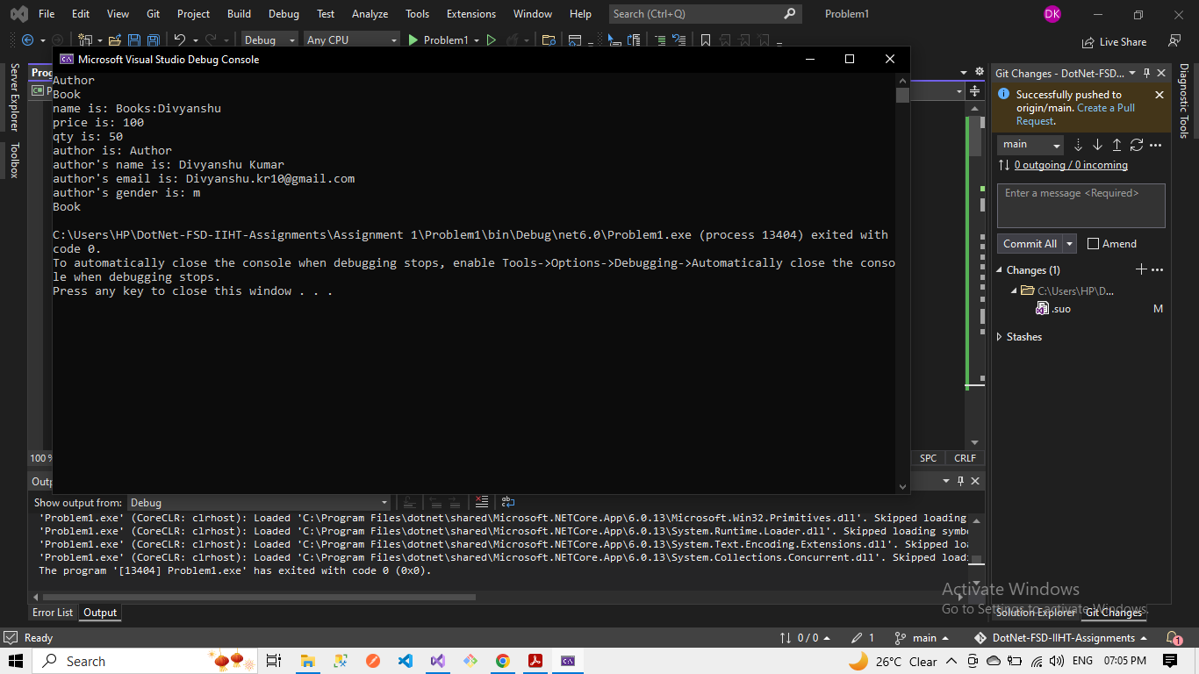

Problem 2:

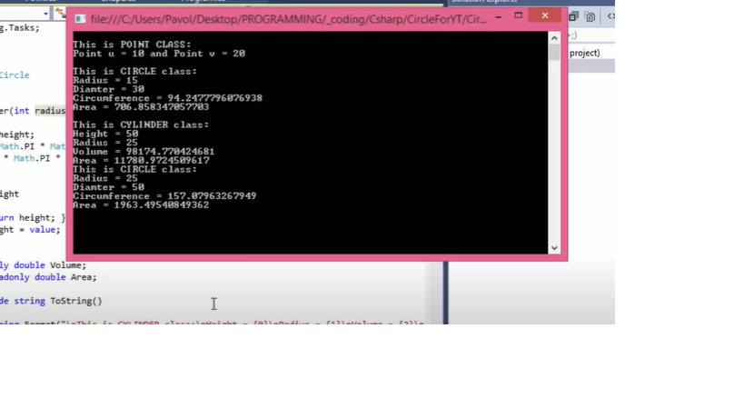

Problem 3:

